Project Implementation Detail

Task1
Description of the task1: Read/Load the dataset file :
Code for task1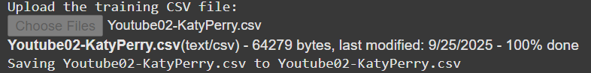
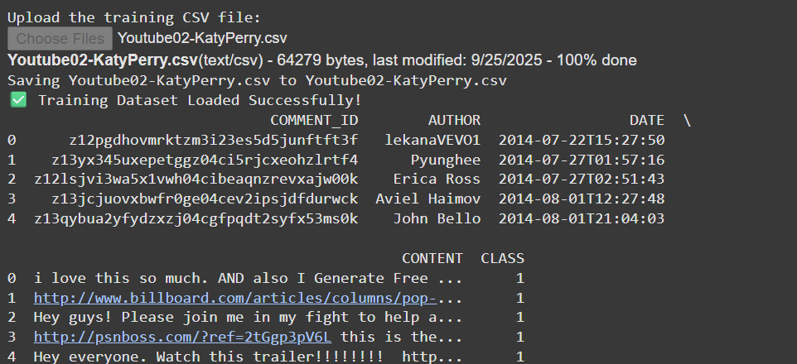

Code description of task1: Load katyPerry.csv file in google colab and show the dataset.
This code is used in Google Colab to upload and read a training dataset from a CSV file. First, it prints a message asking the user to upload the training CSV file. Then, files.upload() opens a file dialog for the user to select the file, which is stored in the variable uploaded. The code takes the uploaded file’s name using list(uploaded.keys())[0] and reads it into a pandas DataFrame called train_df using pd.read_csv(). After successfully loading the data, it prints a confirmation message and displays the first five rows of the dataset with train_df.head(), for example showing a preview like email texts and their labels (e.g., “CONTENT” and “CLASS” columns in a spam detection dataset).

Task2
Description of the task2: Apply appropriate data cleaning techniques to the dataset.

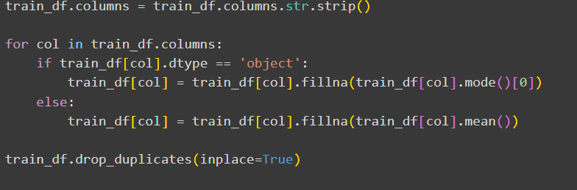

Code description of task2: Clean all the data. If any missing value found we replace it with mean(numeric) / mode(categorical).
First strips extra spaces from column names so that names like " CLASS " become "CLASS", which avoids errors later. Then, for missing values, it fills them differently based on the type of data: if the column is categorical (object type), it uses the mode (most frequent value) because categorical data doesn’t have a natural numeric average, so replacing with the most common value keeps the data realistic. If the column is numeric, it fills missing values with the mean (average) because mean gives a balanced estimate of the missing value without biasing toward one extreme. After that, it drops duplicate rows using drop_duplicates() to make sure the model doesn’t learn repeated patterns multiple times, which could otherwise lead to bias or overfitting. Finally, it makes the CLASS column more meaningful by mapping 0 → Not Spam and 1 → Spam, so instead of numbers, we directly see labels like “Not Spam” or “Spam,” which are easier to understand when analyzing results.

Task3
Description of the task3: Description of the task2: Apply appropriate data cleaning techniques to the dataset.
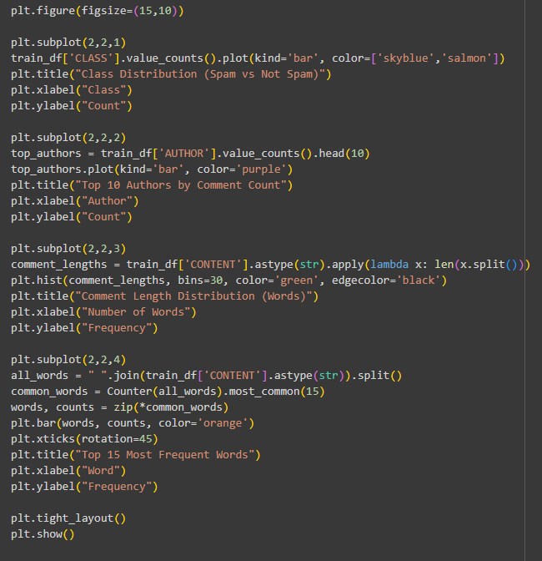

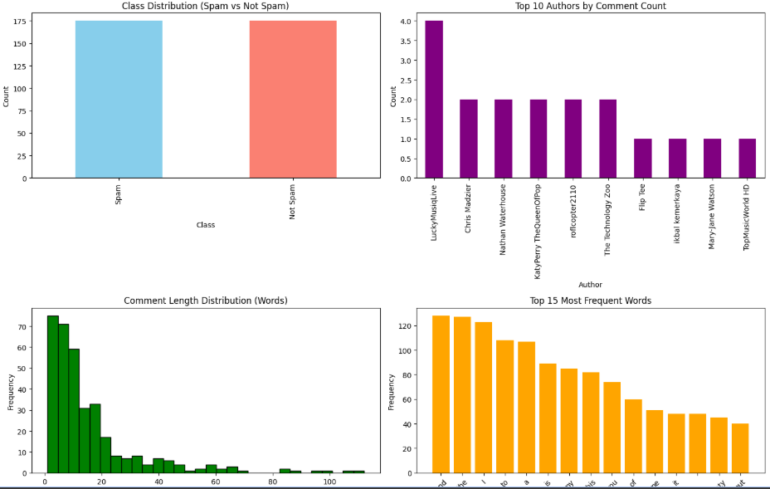
Code description of task3: This block of code is used for exploratory data analysis (EDA) by creating visualizations to better understand your spam dataset.
The code creates a 2×2 grid of plots to visualize different aspects of the dataset. The first plot shows the class distribution, comparing how many comments are labeled as Spam vs Not Spam using a bar chart. The second plot displays the top 10 authors with the highest number of comments, helping identify frequent contributors. The third plot calculates the comment length in words for each text and shows a histogram of their distribution, revealing whether most comments are short or long. The fourth plot combines all words from the CONTENT column, counts their frequencies, and then shows the top 15 most frequent words in a bar chart, highlighting which words appear most often in the dataset. Together, these plots help understand the dataset’s balance, major contributors, text characteristics, and common vocabulary, which are important for building and evaluating a spam detection model.

Task4
Description of the task4: Split the dataset into two parts: Training dataset and Testing dataset
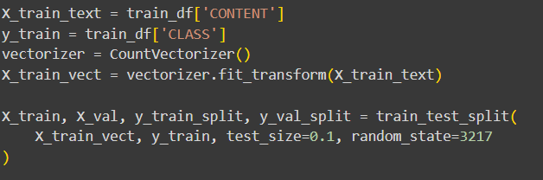

Code description of task4: This code prepares text data for machine learning by first separating the input features (CONTENT, the comment text) and labels (CLASS, Spam or Not Spam). Since models cannot understand raw text, it uses CountVectorizer to convert comments into a numerical bag-of-words representation, where each unique word becomes a feature, and a comment like “Win money now” is turned into [1,1,1] if the words “win,” “money,” and “now” appear once each. This vectorized dataset is then split into two parts: 90% for training so the model can learn word patterns that indicate spam, and 10% for validation to test whether the model can correctly generalize to unseen comments. Splitting is important because testing on the same data used for training could cause overfitting, meaning the model memorizes examples instead of learning useful rules. This processed data will later be used by algorithms such as Naïve Bayes to classify new comments as Spam or Not Spam.

Task5
Description of the task5: We apply Naïve Bayes Classifier to the dataset
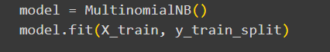

Code description of task5: The code is where the actual machine learning model is trained.
Here, a Multinomial Naïve Bayes model is created using MultinomialNB(), which is especially suitable for text classification because it works well with word count features from CountVectorizer. The fit() method trains the model by feeding it the training vectors (X_train) along with their labels (y_train_split), so the model learns patterns of word frequencies that distinguish Spam from Not Spam. For example, if words like “win,” “free,” “money” appear more often in spam messages, the model will assign them higher probabilities for the Spam class. After training, the model can then predict whether a new unseen comment is Spam or Not Spam based on its word counts.
Task6
Description of the task6: Calculate the confusion matrix
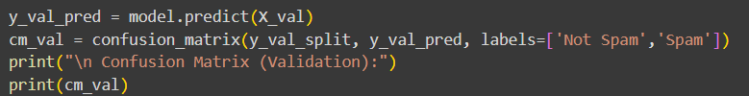
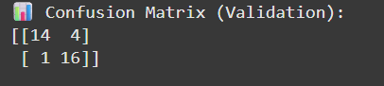
Code description of task6: This code evaluates the trained model on the validation set to see how well it performs.
The model uses predict() on X_val (the validation feature vectors) to generate predictions (y_val_pred) for each comment. Then, confusion_matrix() compares these predictions with the true labels (y_val_split) and organizes the results into a confusion matrix, which shows how many comments were correctly or incorrectly classified for each class. The labels=['Not Spam','Spam'] argument ensures the matrix rows and columns correspond to those classes. For example, if the matrix shows [[90, 10], [5, 95]], it means 90 Not Spam comments were correctly classified, 10 Not Spam were misclassified as Spam, 5 Spam were misclassified as Not Spam, and 95 Spam were correctly classified. Printing this matrix helps you understand the model’s accuracy, errors, and class-wise performance on unseen data.

Task7
Code description of task7: : Calculate the model's train and test accuracy and compare them
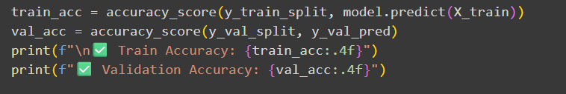

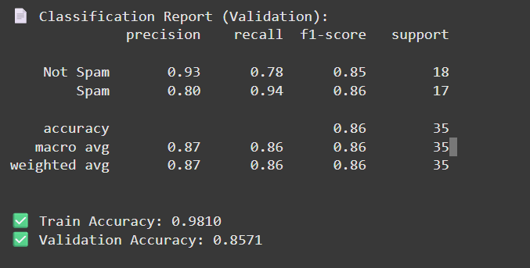
Code description of task7: In this portion of code calculates and prints the training and validation accuracy of your model to see how well it has learned and generalized.
The code first predicts labels for the training set using model.predict(X_train) and compares them with the true labels (y_train_split) to calculate training accuracy, which indicates how well the model has learned the patterns in the data it was trained on. Then, it uses the previously predicted labels for the validation set (y_val_pred) and the true validation labels (y_val_split) to calculate validation accuracy, which shows how well the model generalizes to unseen data. For example, if train_acc = 0.98 and val_acc = 0.92, it means the model correctly classified 98% of the training comments and 92% of the validation comments, helping identify potential overfitting if the training accuracy is much higher than validation accuracy.

Task8
Code description of task8: Create a separate test set and determine its accuracy
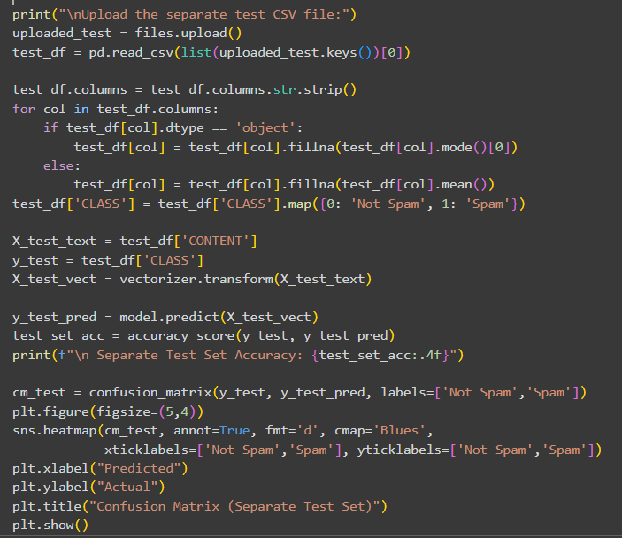
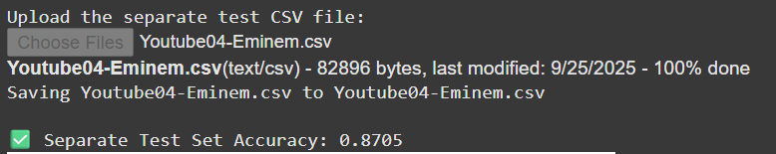
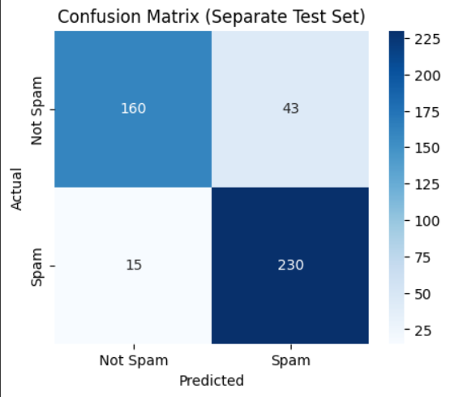
Code description of task8: In this portion of code we use the same techniques as we use earlier in task: 1,2,4,6 and 7 like import the dataset, cleaning it, creating a confusion matrix, and calculating the accuracy

Task9
Code description of task9: 10-fold cross-validation can be used to build a naïve bayes classifier and report the accuracy of this model
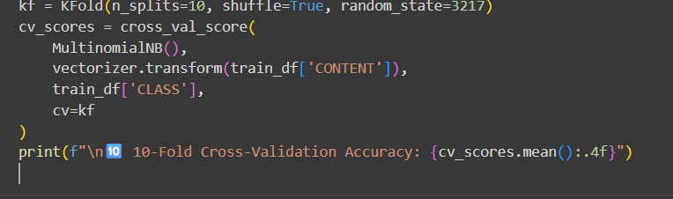

Code description of task9: In this part, we perform 10-fold cross-validation to evaluate the model more robustly on the training dataset.
First, KFold(n_splits=10, shuffle=True, random_state=3217) splits the dataset into 10 equal parts (folds), randomly shuffling the data to ensure each fold is representative. Then, cross_val_score() trains a Multinomial Naïve Bayes model on 9 folds and tests it on the remaining fold, repeating this process 10 times so that each fold is used once as the test set. This produces 10 accuracy scores (cv_scores), which are then averaged to give a more reliable estimate of model performance, reducing the bias from any single train/validation split. For example, if the mean accuracy is 0.915, it means that across multiple splits, the model correctly classifies about 91.5% of the comments, giving confidence that the model generalizes well to unseen data.

